2015 Annual Report
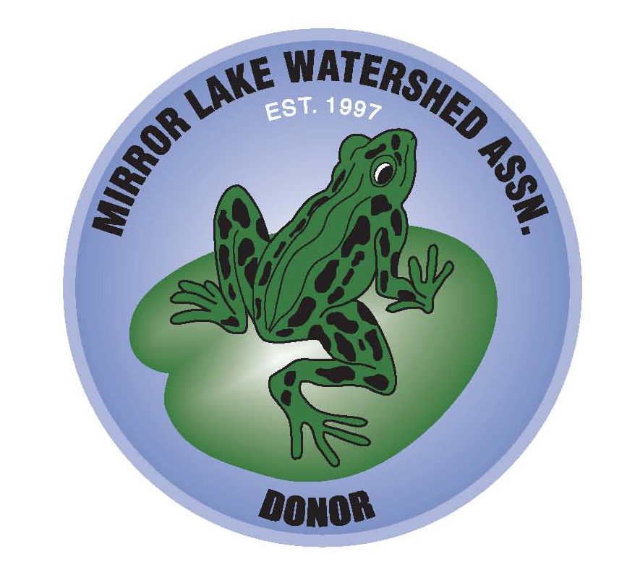
Mirror Lake Watershed Association
PO Box 1300, Lake Placid, New York 12946
www.mirrorlake.net

Greetings,

It’s that time of year when we update you on our activities including our educational outreach work. We invite you to join us at our monthly meetings and ask for your donations and support.

We’ve had a good year. The focus of our activities continues to be raising awareness and protecting Mirror Lake and surrounding water bodies from adverse impacts to water quality. Again this year we increased our efforts to locate and harvest potential new invasive species before they become established.

Year in Review

The Adirondack Park Invasive Plant Program was awarded the Tenth Annual Mirror Lake Watershed Award” (formerly the “Frog Award”) for their efforts in educating the public and controlling invasive plants. The award this year was a bathymetric carving of Mirror Lake.
The Community meeting room at the Peacock Park Beach House was officially named the David H. Ackerman room. The Lake Placid Village Board bestowed this honor on David for his forward thinking on issues affecting the water bodies of Lake Placid and North Elba.
With the help of Brendan Quirion of Adirondack Park Invasive Plant Program, invasive species including Purple Loosestrife and Yellow Iris were harvested and inventoried around Mirror Lake and its watershed. This annual effort to manage and contain the invasive plants has been remarkably effective. Because the plants are not widespread at this point, there is a high likelihood of success in eliminating Yellow Iris and controlling Purple Loosestrife. Other lakes in the Adirondacks have been invaded by Eurasian Water milfoil, Variable Leaf Water milfoil, and spiny water flea. Mirror Lake is vulnerable to these aquatic species and in the future we need to be vigilant to prevent them from invading our lake. We also supported and attended the “Symposium on Invasive Species in the Adirondacks” at Heaven Hill Farm.
A deep water cleanup was conducted in the early summer by a group of divers coordinated by Jim Grant. Bottles, cans, fishing lures, towels, and even a park bench were pulled out of the lake with the assistance of the MLWA.
Mirror Lake water quality continues to be monitored. MLWA volunteers took water samples for testing by DEC, and Ausable River Association staff took samples for testing by the Adirondack Watershed Institute at Paul Smiths College. Test results from 2014 and preliminary results from 2015 indicate a potential problem with the chloride concentration in the deeper waters of Mirror Lake. Additional testing through the winter and spring is necessary to validate the preliminary results. Phosphorus levels, while slightly increasing, are still relatively low and algae levels remained low, consistent with the oligotrophic classification.

Our website, www.mirrorlake.net, has been updated with new information and has many informative articles about the issues facing Mirror Lake.

-continued-

Looking Ahead - Goals for 2016

In the coming year the MLWA has set the following goals:
- Seek funding from the Lake Champlain Basin Program and other sources to further the final engineering design on stormwater improvements on the East side of Mirror Lake.
- Work with the Lake Placid Village on permit conditions for the use of Mirror Lake during events.
- Work with the Village to keep the lake clean following increasing winter recreational use.
- Continue to inventory and control Purple Loosestrife, Yellow Iris, and Japanese Knotweed, and continue searching for potential new invasive species, especially watermilfoil; continue to monitor the successful loosestrife beetle release at Mill Pond to control the invasive Purple Loosestrife and consider adding beetles to a persistent patch of Loosestrife on the shores of Mirror Lake.
- Research and publish monthly articles about the issues facing Mirror Lake.
- Work with the Village, Town, and State DOT officials to reduce the amount and frequency of road salt applications on the roads and walkways around the lake.
- Work with the Ausable River Association to help to implement a watershed management plan for the upstream areas on the West Branch of the Ausable and the Chubb River when the plan is finalized in the coming months.
- Research and promote more “lake friendly” products such as locally available salt-free ice melting agents and non-phosphate lawn fertilizers.
- Continue the ongoing effort to clean-up Mirror Lake’s underwater and shoreline refuse.
- Continue to seek reductions in the impact of stormwater discharges from the west side of Mirror Lake.

The above goals are in addition to our regular activities, which include storm drain stenciling, shoreline cleanup, “Poop Scoop”, and the placement of posters to increase awareness. Please check out our recently updated web site, www.mirrorlake.net, which contains information on supporting the funding of our projects….we can all make a difference!

As you can see 2015 has been a busy year, but this coming year we hope to top this past year’s activities. If you have an interest in the well-being of our precious Mirror Lake, please join our team. We meet the second Monday of every month at 5 pm at the David H. Ackerman Room in the Peacock Park Beach House, or you may contact Bill Billerman, our chairman, at 524-4328. The MLWA is an entirely volunteer organization with no paid staff or office.

Cordially,
Mirror Lake Watershed Association / Water Management Committee

Bill Billerman – Chair
Mark Wilcox – Treasurer
Mitch Goroski – Secretary
Shawn Ayers Nev Dunn
Denise Bujold John Eldridge
Conni Cross Georgia Jones Ray Curran Larry Master
Bob DiMarco Margaret Murphy

